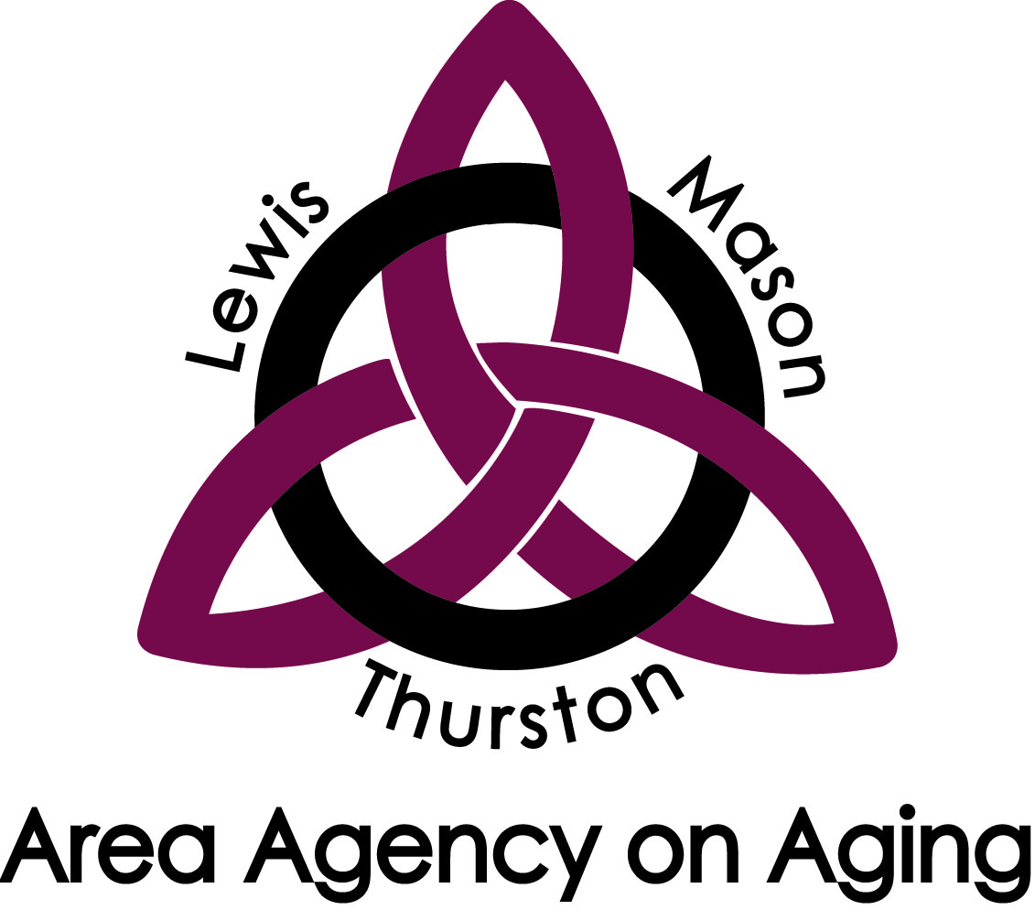
Lewis - Mason - Thurston
Area Agency on Aging

2404 Heritage Ct. SW
Olympia, WA 98502
Phone: (360) 664-2168 • Fax: (360) 664-0791 • www.LMTAAA.org

Advisory Council
Draft Meeting Minutes for Wednesday, April 3, 2024
9:30 AM – 12:00 PM
In Person & Via Zoom
Members Present
Lewis County: Debbie Aust & Tim Wood
Mason County: No members present.
Thurston County: Cat McGaffigan, Chair, Ellen Wendt, Michele Horaney, Angela Hock & Anna Schlecht.
Members Absent – Heidi Buswell, Vice-Chair, Lewis County, Greg Rohr, Lewis County, Becky Cronquist, Mason County, Stefanie Herman, Mason County & Eileen McKenzieSullivan, Thurston County.
Staff Present
Nicole Kiddoo, Executive Director, Jemma Williamson, Deputy Executive Director, Carrie Petit, Contracts Director, WinDi Sanchez Soler, Administrative Secretary.
Guests Present
Jamie Queen, Prospective New Member
Welcome and Introductions, Cat McGaffigan, Chair
Cat welcomed everyone and noted that because there was not have quorum, motions will be informational and not voted on unless more members join.
Approval of the April 2024 Draft Agenda and March 2024 Draft Minutes
This was tabled until later in the meeting when there was a quorum.
USAging D.C. Meeting Debrief, Nicole Kiddoo, Executive Director & Carrie Petit, Contracts Director
Nichole shared that the policy briefing provides an opportunity to take information to the hill and to the delegates for our area. They had to divide and conquer as the Capitol campus is large but were able to participate in all of the scheduled meetings. Becca Frisch attended as our Communication Manager. Nicole advised the council to follow the agency’s Facebook page, as we post a lot of information there. To access the page, type Lewis-Mason-Thurston Area Agency on Aging into the Facebook search bar. Carrie shared that it gave her a sense of comradery to see other AAAs from around the county dealing with the same issues that we are. Being able to meet the Senators and Representatives or their staff in person was a great experience and they genuinely wanted to hear from us. She is grateful for their support because, with it, we do not have to fight as hard to get their approval.
Older Americans Act Reauthorization, Nicole Kiddoo, Executive Director
Nicole Kiddoo shared that this year is pivotal for the Older Americans Act (OAA). There is not enough money going around for all the people who need this program so there are targeted sections we are focusing on with the help of this council to make sure all available funds are allocated to the areas we see the most need. The Senate Health, Education, Labor, and Pension (H.E.L.P.) Committee wanted information from us. We have already responded locally and nationally because they had a quick turnaround deadline. The response sent to the Senate H.E.L.P. Committee was an edited version of the policy priorities list previously sent. While this reauthorization is happening, we want to focus on all the services listed as there is an opportunity for anyone to come in and advise where the funds could be used or who can manage them. Carrie Petit explained that during this pivotal moment, it is important for us to create and prioritize what will help the diversity of communities we serve. Nicole added that we would like Council members to host listening sessions, both in person and online, within their communities to share what OAA reauthorization is about and where it is going so that AAA has information on what to prioritize by this summer. We are wanting to hear from people who are affected by OAA currently. We have agency staffing to help with these sessions that have a deadline of September 30th. AAA’s will gather information from the National level at the U.S. Conference on Aging this summer. Nicole will guide the Council on who to reach out to, send letters, or make phone calls to talk about the totality of the OAA but she is leaning on Council members to help with the venues and attendance. Further discussion on meeting locations and who to invite were had and it was decided that community events will be a great resource. Nicole then tied in Washington Cares Fund as a topic that should also be discussed at these listening meetings. Our role in helping to build WA Cares is making sure that we know how many community members will be tapping into it so that we can make sure we have providers that can serve these people. There was a discussion on how to get the WA Cares presentation and it was decided that the presentation is will eventually be available to the communities. Further discussion was had on the listening session deadlines and Nicole mentioned that Senior Executive Assistant Sarah Cockrell will be coming on for support and she will coordinate with Lisa Bachmann as the liaison to figure out when these discussions should happen. Concerns regarding the risks of OAA funding dilution with the addition of WA Cares were discussed and it was decided that service providers that are involved in OAA will hopefully be doing some WA Cares work as well, especially in rural communities, so there is no risk of dilution from that perspective. Nicole elaborated that WA Cares benefits will be available the following year after OAA is reestablished, so we need to understand community needs and desire to use these benefits as there is not a lot of data available for WA Cares at this point. Further discussion on where WA Cares is in the political landscape occurred and it was noted that it is on the ballot, and we are not concerned about it being overturned at this point. Michele Horaney added that Washington State is the first in the country to implement WA Cares so we should expect some challenges. She suggested the council emphasize the values of the program and what it can do for individuals.
The AAAs are receiving money to provide unbiased information and education about the program. Planning Manager Kyle Sanchez mentioned that we have had problems with people not wanting to hear about the program. There was discussion on ideas of how to get this information out in an unbiased way. Recommendations included a one-page information documents; focusing on all age groups; attending public meetings; exploring social media; newsletters; and providing a link to the WA Cares website informational video.
Participation in OAA Month, Cat McGaffigan, Chair
Cat shared that the Older American’s Act (OAA) month is in May. We have a proclamation that is written and ready to go. Nicole stated that we want to get the Councils help to get the proclamation on the docket. Debbie Aust said she attends most of the board of County Commissioners meetings so can bring the proclamation to the meeting. Tim Wood asked to be notified when Council members will be attending these meeting so that he can attend as support. It was clarified that this proclamation is for all three countries.
Revisited Approval of the April 2024 Draft Agenda and March 2024 Draft Minutes
Cat McGaffigan requested the council revisit the agenda and minutes for approval as there was now a Quorum with Michele Horaney joining.
Michele Horaney made the motion to approve the April Agenda and March Minutes. The motion was seconded by Debbie Aust. Cat McGaffigan asked for any discussion or corrections. It was suggested that the agenda be approved with the title after Nicole’s name corrected and the with the word ‘let’, changed to ‘led’ in the minutes under the topic of goals. Tim Wood asked if it is within the guidelines for him to vote to approve if he was not in attendance at the previous meeting. Nicole Kiddoo said that Tim Wood can abstain. The vote to approve the draft agenda and minutes was approved unanimously, with Tim Wood abstaining.
2024 Advisory Council Goals, Cat McGaffigan, Chair
Cat updated the Council on the Advisory Council 2024 goals draft, stating that she, Heidi and Lisa worked on the goals and tried to narrow them down to concise definitions which would allow for flexibility in our outreach work. Members should have received an email copy. We want to make sure our roll of an Advisory Council is clear as well as the expectations between the Advisory Council and staff. The goals are divided it into three sections. The first goal is advocacy and education with a focus on the OAA reauthorization. There was discussion of how much of the focus on advocacy should be at the local level and how much at the national level. Nicole noted that the focus on federal legislation is increased this year because of OAA reauthorization. It was suggested to keep advocacy on both levels. Cat stated that the second goal identified is the education of the Council and that they have been working on that through invited guest speakers. The more we understand about the work that AAA is doing, the more we can talk to the community. Also, included with this will be the upcoming DEI trainings. This will help with the group know how LMTAAA interacts with the community and so help them with their interactions as well. It is also helpful to have information about the partner agencies that the agency works with so when they talk to the community there is a good understanding about what AAA does. She said this could be added as a non-mandatory goal to educate ourselves better about AAA and partner agencies. Cat shared that the third goal identified is outreach efforts, which includes taking the information we have learned about the agency and legislation and giving it to the community. An example is the topic of housing, and the work Anna Schlecht is doing. We want to continue having forums about the needs for housing in the community so we can take that information and talk about it. One area we can better understand the agency and the community is by supporting the agency’s open house events. Nicole noted the first one was at the Olympia building in October 2023. Carrie shared that the next open house will be in Lewis County at the Chehalis building on Thursday May 16th, from 4:00-6:00PM. Nicole shared that Becca Frisch is getting a press release out about the open houses and the next Thurston County one will be October 24, 2024.
Angela Hock discussed how the lack of caregivers that is affecting the community and asked the Council if there is a way to increase the number of caregivers or let people know that this is a problem. It was decided that this is a national problem that does fit into the reauthorization of the OAA, and the council can increase awareness and better understand the issue by sharing webinars. Virtual appointments were discussed as a temporary solution and emphasis was placed on educating the community to raise awareness. The Council discussed barriers they may be able to help with such as caretaker background check turnaround time and recreational drug use is factored into caretaker hiring decisions. It was determined that these issues are being addressed between AAA and CDWA and Nicole will let the Council know how they can help advocate in future meetings.
Reports
Community Updates & Announcements
Tim Wood inquired about the status of open seats on the Advisory Council. Cat McGaffigan noted that we have two members in process of being approved. Tim mentioned he knows a presenter that worked with multi-generational people that would be a great addition to the council. Cat shared that the Membership Committee has been working on filling the vacant seats and that Debbie Aust and Greg Rohr plan to network in Lewis County in hopes of having a full roster. Cat suggested members recruit at the OAA and WA Cares listening sessions.
Michele Horaney announced that they are still working on the Village-to-Village movement. They found that there is already one in their community, however, there is very little information available about them on their official site. Discussions were had on how to connect AAA with the Villages and suggestions included inviting members to Council meetings and promoting the movement within the community as a resource people can use to socialize.
Cat announced that the South Sound Dementia Conference will be held at Saint Martin’s University on May 11th from 9:00 AM to 3:00 PM. There may be a $5 donation. She also believes the Pride Festival would be a great event for Advisors to attend.
Ellen announced that Commit to Connect is holding its annual National Summit to Increase Social Connections in May. Cat added that the conference will be held virtually on Webinar. Ellen and Angela have signed up to attend.
Socialization & Engagement Committee, Angela Hock
Angela Hock shared that that the committee is working on condensing their flyer. Val Aubertin brought some information to their meeting about South Sound Senior Services (SSSS) and implementing measures to emphasis the issues with isolation and loneliness. Angela mentioned the ServTracker program as one way to track this issue. Ellen Wendt is looking for something she can do in May to help bring attention to Older American’s Month. She met with Jill Rector, manager at the Lacey Senior Center, to discuss ways the center could help increase awareness, but unfortunately, there did not seem to be much interest for the Lacey Senior Center to partner with us. Angela stated that she attended another meeting with Brian’s discussion group. They mentioned meeting up with the United Way, the city finance person, and the YMCA to talk about how isolation can be alleviated. Angela is thinking of doing an outreach event talking about isolation in the community. She will let us know when they have more details to share. Angela also shared that Brian is inviting people to collect $1000 for the senior center. If you are successful, you may get to repel down a building.
Housing Committee & Charter, Anna Schlecht
Anna shared that the Housing Community has been in the process of due diligence by meeting with Lewis County representatives. Nicole met with Lewis County Commissioner Sean Swope, and they will be holding another meeting later this month. Anna met with Eric Isenberg and Deputy City Manager Amy Buckler to talk about where to hold a forum, who will be on the panel, and who to invite. She said they are still in the information gathering stage, but they think they will be meeting in September at the Trans Alta Commons. The event will include anyone involved in the aging community. Anna stated the ultimate goal is to raise awareness of the needs for housing in the aging community and strengthen the networks for providers that are already working in that industry. Tim shared he would like to attend these meetings to show support. Anna explained there is some disconnect and conflict between the three counties so it would be helpful for Tim’s input since he is a Lewis County resident. Nicole recommended Council members attend the Board of County Commissioners (BoCC) Meeting on April 23 at 3:30 as it is in relation to Lewis County Seniors.
Advocacy & Legislative Committee, Michele Horaney
Michele shared that Advocacy & Legislative Committee is currently quiet as all our state representatives went home. They are looking forward to January 1, 2025, when the Legislative Session resumes, to resume advocating for asks that did not happen last year such as funding for case managers. Michele predicts there will likely be other exciting bills we will study and advocate for in the next year.
State Council on Aging (SCoA), Michele Horaney
Michele Horaney discussed some of the points from her report that was sent out to the members prior to the meeting. The council is hoping for a resolution soon regarding the mission statement for the SCoA. Currently, the statement says they are supposed to be given documents that have to do with aging, review them, and advise the state governor on them. However, they have not received these documents to review, nor had feedback for the governor. Bea Rector, Assistant Secretary for ALTSA and liaison to the office of the Governor will be setting up a meeting in the next few weeks to reassess the RCW and mission statement. Michele explained it seems that the council only exist right now because they must be for federal funds to be passed. Michele stated there are 17 members that are appointed to this group that meet via zoom to share information, bring up issues, and let everyone know what they do. However, they are supposed to look at these federally funded programs and talk to the governor about what they found and if they advise the governor to support them or not. Some concerns were shared about the political bias seen in the Senior Newspaper. Michele clarified that the SCoA is not tasked with oversight of that publication and Carrie Petit added that the Senior Newspaper is run by a nonprofit organization.
Additional Comments from the Housing Committee
Ellen shared that she found out that the residence of Tumwater Mobile Estates, a 55+ residential area on Trosper road, contacted lawyers and financial sources that deal with this type of situation and have subsequently started a co-op and now they own the residential facility. Anna requested Ellen find out more information about who the residence contacted. Ellen responded that she would contact the manager of the co-op for more information.
Adjournment
A motion was made to adjourn the meeting by Tim Wood and seconded by Debbie Aust. It was unanimously decided to adjourn. The meeting ended at 12:08 PM. The next scheduled meeting is on May 1st at 9:30 AM.
Minutes taken by
___________________________________________________
WinDi Sanchez Soler, Administrative Secretary

